NOTES FROM THE DIRECTOR – 2/18/2022

NEW EDUCATIONAL PIECES:

Two new pieces of taxidermy have been completed and now can be used for educational programming and exhibits!

Welcome the red squirrel and
immature northern cardinal

Taxidermy is an important tool in environmental education. It allows many educational opportunities including, closeup views of animals to better understand their physical adaptations and natural beauty – without them dashing and flying out of view.

US ARMY CORP OF ENGINEERS:

The US ACE provided a technical presentation in late January. The data collected was a 5-month snapshot for the selected area of study. Additional research may be required to gather further data for a more complete understanding of the waterflow and what options there are for address issues on the site without causing other issues.

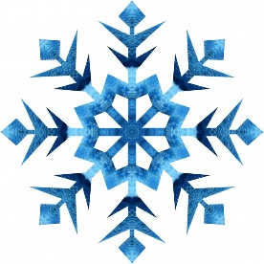
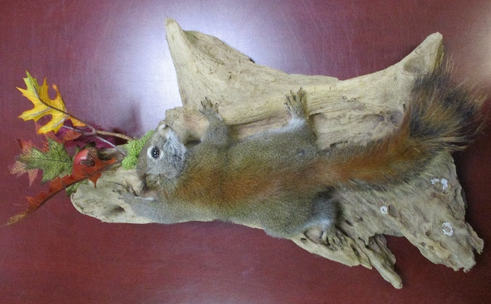

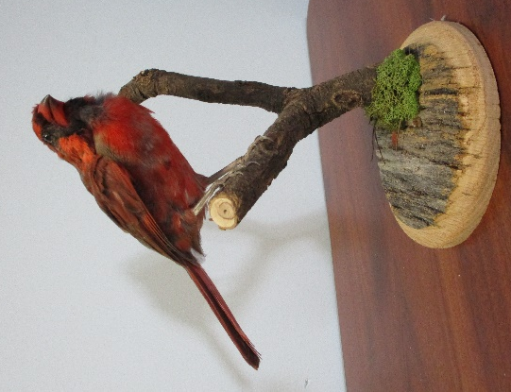

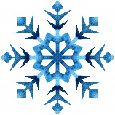

PUBLIC PROGRAMS, PARTICIPATION, & PARTNERSHIP SUMMARY

OCVN Class Planning for this fall as begun!
We are excited to be planning a second class for Seneca County, tentatively scheduled to begin in August 2022. More details to follow soon!

GENERAL PROGRAM REGISTRATIONS:

 | Jan (2021) | Total
Programs | 26 (22) | 26 (22)
Participants | 202 (243) | 202 (243)
2020 #s - Some programs cancelled in March, all programs cancelled throughout April and May.

WEBSITE UPDATE:

The new website is up and running. We will go through training with Spire soon so we can make basic alterations and updates in the future.

OPPORTUNITY PARK – OHIO CAPITAL BUDGET PROJECT:

Equipment and safety surfacing has been ordered! A demolition/site preparation time line is tentatively scheduled for Saturday, April 2 – Friday, April 8 with more details yet to be determined.

INVASIVE SPECIES REMOVAL:

We met the 4 Thursdays in January to begin invasive species removal along the trail in Clinton Nature Preserve and Schekelhoff Nature Preserve.

We will not be doing removal in February, but will pick back up again in March, April, and May with more dates and times available. Watch for dates and times posted on the park website and Facebook page.

This is a cooperative effort with Tiffin Park & Recreation Department, Heidelberg University, and the Sandusky River Watershed Coalition.

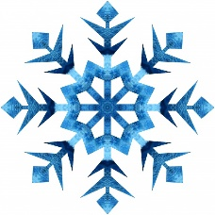

INVASIVE SPECIES REMOVAL (continued):
Invasive species have a variety of impacts. Attached are two articles found online that provide insight into why invasive species removal is so important:
https://www.naturalland.org/study-says-honeysuckle-leaves-impact-water-quality/

Study Says: Honeysuckle Leaves Impact Water Quality
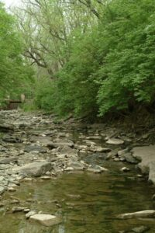
Natural Land Institute has been fighting the growth of bush honeysuckle (Lonicera maackii) in the wooded areas of our preserves for many years. Bush honeysuckle (from Asia) doesn’t have natural competitors here and therefore, grows aggressively making it impossible for other plants and trees to produce wherever it grows. A healthy wildlife habitat needs a variety of plants and animals. We know what it does to the land, but until recently, we didn’t know about honeysuckle’s impact on water.
A study conducted by a team from Northern Kentucky University found that leaves from bush honeysuckle that fall into water produces an undesirable effect on the quality of the water, as well as harm aquatic species, such as the wood frog. Read more about it here: https://landairwater.me/2020/12/10/honeysuckle-water-quality/
Call the NLI office at 815/964-6666 (or send an email to info@naturalland.org) to request one or both of the following brochures be mailed to you. They provide great tips on what to plant in your yard: “Healthy Hedges” and “Healthy Home Landscapes”.
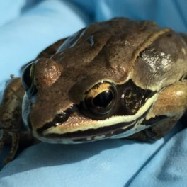
https://www.indystar.com/story/news/environment/2020/08/07/cheating-olympian-why-honeysuckle-does-not-play-fair/5478423002/

A cheating Olympian: Why honeysuckle does not play fair
Lorena Villanueva-Almanza
Published 5:00am Aug. 7, 2020, updated 1:11pm Aug. 8, 2020
Honeysuckle’s fragrant flowers have inspired the smells of soaps, perfumes, and body lotions — but, alas, honeysuckle is not as sweet as it seems.
Decades of research show this shrub, native to eastern China, Korea, and some regions of Japan, has a dark side. Because of some special characteristics, honeysuckle has the devastating ability to choke-out native plants, thus potentially causing considerable harm to forests in Indiana and the eastern U.S.
Last March, Indiana’s Terrestrial Plant Rule banned the sale, gifting, exchange, distribution, and introduction of 44 invasive species, including Asian bush honeysuckle. These seemingly inoffensive shrubs have an entire arsenal to reproduce and destroy whole ecosystems.
Lenny Farlee, an extension forester with the Hardwood Tree Improvement and Regeneration Center at Purdue University Department of Forestry and Natural Resources, explained that invasive plants are non-native species that are harmful to the environment, the economy, or human health.
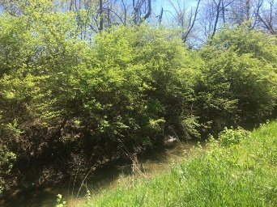
“The reason a lot of these are a problem is that we take them from someplace else and introduce them here (where) growing conditions (are) much better than where they originally came from,” Farlee explained “(They are) able to grow faster in the environment, where they don’t have predators, or diseases.”
Invasive species:These common landscaping plants are now illegal to sell in Indiana
These super competitors are not only able to survive, but also excel at producing seeds.
Honeysuckle shrubs are rooted in the ground, but they can still "move." Birds carrying honeysuckle seeds take the invaders places they would not be able to go by themselves. After the scented flowers turn into colorful fruits at the end of the summer, birds feast on the fleshy berries, and then fly and spread the seeds with their droppings.
Birds aren't the only honeysuckle spreader. Water also transports the berries.
These shrubs also follow the “live fast” principle by making numerous and quick-growing stems. And these are not picky shrubs: Unlike other plants, honeysuckle grows well under different light conditions. It also does not invest too much in making a sturdy frame; instead, it produces hollow stems, allowing it to grow faster.
This makes open forests a playground for honeysuckle. Less dense woodlands have more available light, which the shrub will waste no time in using to make more fruits, leading to even more seeds and higher invasion.
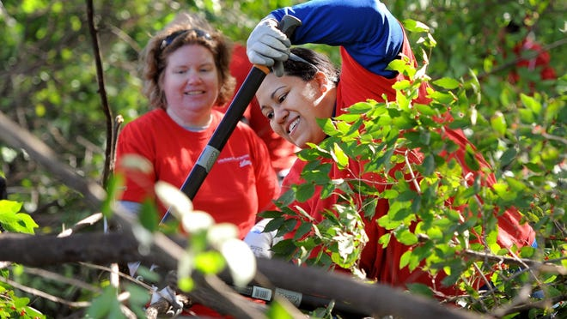
It does not take long for honeysuckle to take over. Farlee noted these precocious shrubs can start producing seed when they are three or four years old.
And if all that wasn't enough, honeysuckle also has the capacity of giving itself a head start: Leaves grow a couple of weeks earlier and fall later than those of the surrounding native species. This means honeysuckle has more time to absorb nutrients and energy to grow and produce more fruits.
Oh, and its leaves also resist freezing.
When it comes to competing with others, honeysuckle is like an Olympic sprinter. On serious performance enhancing drugs. With a 20-meter head start.
“They're just so good at getting all the resources for themselves,” said Victoria Schmalhofer, assistant director of the Center for Earth and Environmental Science at Indiana University-Purdue University Indianapolis.
Dense layers of honeysuckle make it almost impossible for seeds of native plants to germinate. And when they do, the shading from the shrubs prevents them from growing.
The issue with choking out native species goes beyond nostalgia: It also creates problems for forest-dwelling creatures and water quality.
Once honeysuckle takes over, it might be easy to believe that one hue of green has replaced another. But beneath the green façade hides a soil erosion problem.
The roots of native plants are effective in holding soil together, preventing nutrients and sediments from being washed out during rains. However, honeysuckle's roots are shallow. When honeysuckle displaces native plants, its shallow roots leave soil particles at the mercy of the elements.
“You now have this water moving over bare ground, and it's going to pick up sediment. When it makes its way into the streams it's going to have a higher sediment load,” Schmalhofer explained. “This sediment pollution is the major pollutant in Indiana waterways. Probably the major pollutant in a lot of waterways, across the country.”
An absence of native species is not only bad news for water quality and the local flora. It also creates problems for other species. For example, bats live in large native trees during summer, but honeysuckle has created a housing shortage by holding back the growth of hickories, maples, and elms.
“The negative impacts of the honeysuckle will just mean it's going to take that much longer before a hickory would get to be of sufficient size that would really be an adequate roosting site for the bats,” said Schmalhofer.
Invasive plants also mean trouble for insects. Around 90% of plant-eating insects feed on native plants, according to the Indiana Native Plant Society. Many of these insects are food for the bats, so honeysuckle creates a whole cascading effect.
“I encourage people to scout their properties. See if you can identify these invasives,” Farlee said. “If you can't get a positive ID, you can send pictures to folks like me.”
Farlee said those interested can contact him through email at lfarlee@purdue.edu, and also recommended downloading an identification app on the phone, such as the Great Lakes Early Detection Network app.
Farlee also recommended removing plants while they are still young, as it will be easier. When dealing with adult plants, the use of herbicide is almost inevitable because cutting them will not be enough.
Farlee explained that, even when large plants are completely cut down, the remaining stump is able to grow back in no time.
Once honeysuckle is finally out of people’s homes, it is best to replace them with native species. Dogwoods and Viburnums are fair game. Some specific alternatives are Grey dogwood, flowering dogwood, southern arrowwood, and blackhaw viburnum.
The Indiana Native Plant Society offers more suggestions.
For landowners in rural areas with farmlands or wildlife habitat, Farlee mentioned the US Department of Agriculture launched a farm program to help control invasive plants such as honeysuckle.
Once the problem is beyond the backyard and honeysuckle spreads out into the forests, its removal requires teamwork. The Nature Conservancy has partnered with Cooperative Invasive Species Management Areas, The Indianapolis Garden Club, park departments, local organizations and volunteers to remove invasive plants in what they call Weed Wrangles.
Information on the upcoming wrangles and sign-up information can be found online.
“The amount of work these people can do is amazing”, said Dawn Slack, Director of Stewardship and Chair of the Invasive Plant Advisory Committee at the Nature Conservancy.

-----------------
Lorena Villanueva-Almanza is the 2020 AAAS Mass Media Fellow at the Indianapolis Star. She earned her PhD from the University of California Riverside in 2019 where she studied the taxonomy and ecology of Washingtonia, a group of palms found in southern California and Baja California, Mexico. She’s on Twitter as @lorevial.
IndyStar's environmental reporting project is made possible through the generous support of the nonprofit Nina Mason Pulliam Charitable Trust.

