

**NOTES FROM THE DIRECTOR – 3/8/2022**

**NEW FUEL CARDS:**

To improve efficiency, we have set up a Fuel Man Fleet Card for all Park vehicles. It is working well so we can fuel up at various locations across the county when needed.

**WEBSITE UPDATE:**

The new website is up and running. Spire has trained staff so we can make basic alterations and updates now.

**OHIO COOPERATIVE PURCHASING:**

The one-time resolution on the agenda for this month officially adds the Seneca Parks to the list of members who are able to participate in the State of Ohio Cooperative Purchasing Program administered by the Ohio Department of Administrative Services (DAS).

**OPPORTUNITY PARK – OHIO CAPITAL BUDGET PROJECT:**

A demolition/site preparation time line is still tentatively scheduled for April 2 – 8 with more details yet to be determined.

**INVASIVE SPECIES REMOVAL:**

Thursday, March 10 from 1pm – 2:30pm. We will be meeting at the Schekelhoff Nature Preserve parking lot.

A complete list for March & April will be posted soon on the park website & Facebook page.

**If groups are interested in setting up community service times for their groups**, please contact Sarah Betts at sbetts@senecacountyparks.com.



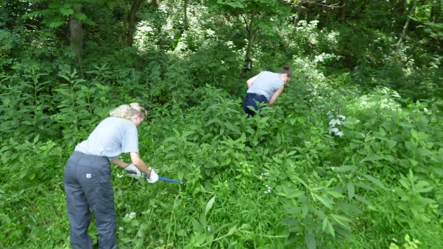



**PUBLIC PROGRAMS, PARTICIPATION, & PARTNERSHIP SUMMARY**

Warm weather is coming…

Summer Camps are being planned 😊

**GENERAL PROGRAM REGISTRATIONS:**

|  |  |  |
| --- | --- | --- |
|  | Feb (2021) | Total |
| Programs | 26 (20) | 26 (42) |
| Participants | 202 (236) | 202 (479) |

*2020 #s - Some programs cancelled in March, all programs cancelled throughout April and May.*

**US ARMY CORP OF ENGINEERS:**

The data collected at GHNP was a 5-month snapshot for the selected area of study. Additional research may be required to gather further data for a more complete understanding of the waterflow and what options there are for addressing issues on the site without causing other issues.

**Possible Options for further study by US ACE:**

1. **Extend Scope of PAS Technical Assistance:** If there are additional technical components relating to the Lake that you would want further evaluated (like for instance additional hydrologic investigation), we could rescope and redevelop an agreement for us to provide additional technical analysis.  Like this recent effort this would need to be cost-shared 50-50, and would provide a tech report, but could not produce detailed site designs or plans.
2. **Aquatic Ecosystem Restoration Feasibility Study under Section 206**:  If you wanted to continue partnership with USACE on a feasibility study that could lead to construction this would be the pathway.  This would probably take 3-4 yrs and would result in the development of a feasibility study that recommends a plan, development of detailed designs, and ultimately implementation of the project.  The costs of project components would be cost share 65% fed and 35% non-fed.  The challenge with this path is it tends to be quite expensive for partners.  Typically our feasibility studies cost ~400-600K, so that would equate to ~$140K to $200K in cost share from the cost share sponsor just for the feasibility study.