NOTES FROM THE DIRECTOR – 3/8/2022

OPPORTUNITY PARK – OHIO CAPITAL BUDGET PROJECT:

OP Demo Days went very well! (See pictures on right)

Thanks to all the efforts from Marta Mohr, Lew Hurst, and other staff from Opportunity Center, Leadership Seneca County Class of 2022, Seneca County Commissioners, Seneca County Regional Planning, Seneca Parks Staff, Tiffin University Football Team, Heidelberg University Football Team, Mercy Health, AJ’s Pizza, and the many others who helped to make this such a success.

The equipment and materials removed from the playground are to be used by the village of Bettsville in their new park location.

Installation of the new play equipment and safety surface at Opportunity Park is still planned for mid-May. After installation, a community ribbon cutting event will take place. Watch for more details.

US ACE & TNC:

After the March Board meeting, I had further discussion with the US ACE regarding the next phase of data collection. They recommended using a local source for further study or contracting with a restoration firm for planning assistance, since they were not able to provide further water quality collection and their planning would be extremely costly. As one door closes, another opens…

Heidelberg University / National Center for Water Quality Research met with me on-site to develop expanding data collection this year to also include the water coming from the north (Bloomville) that was not previously sampled.
Around that same time, The Nature Conservancy (TNC) reached out to me to see if we had possible projects in the Sandusky River Watershed – with one focus of attention at GHNP. They said they would be interested in learning more about the site with the possibility of funding restorations to the site. A tentative meeting is being planned for late spring/early summer with TNC, Heidelberg, and the Parks.

Opportunity Park Demo Days Pictures

Friday, April 1: YES – that is snow!
Friday was a chilly, breezy, rain-snow-sleet filled day. Thanks again to Tiffin University Football team for accomplishing so much in some not-so-pleasant weather!

Saturday, April 2: Leadership Seneca County led this Demo Day with a morning and afternoon shift of volunteers.
Thanks to everyone for helping to accomplish this so quickly - in two days!
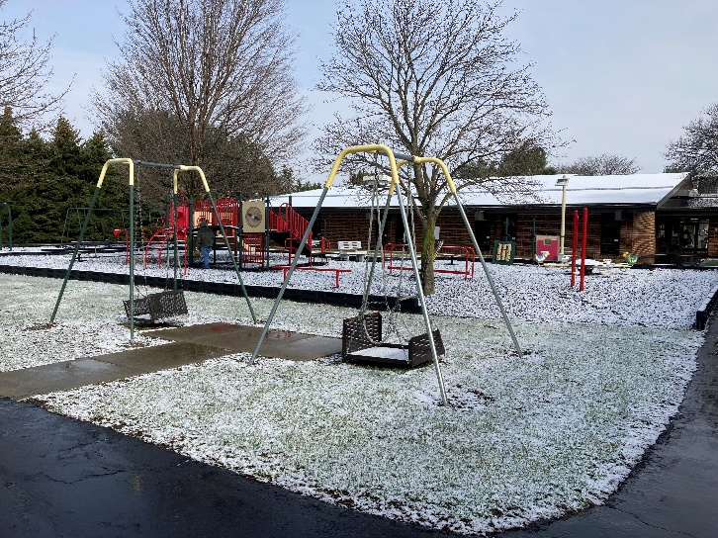

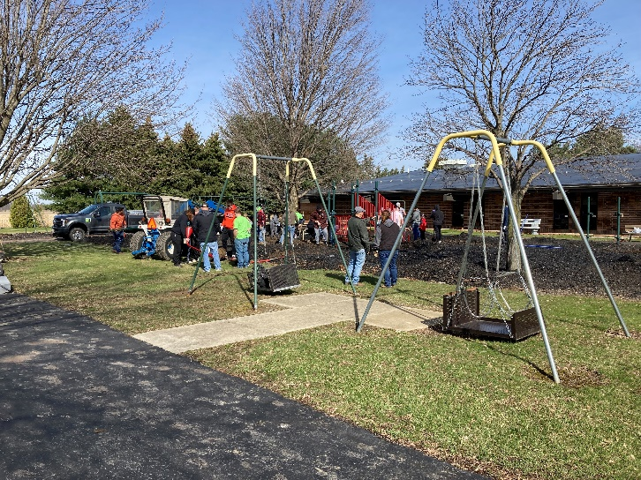

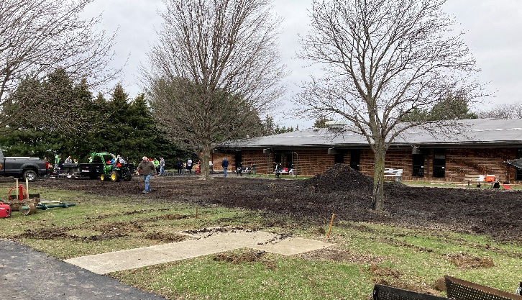

PUBLIC PROGRAMS, PARTICIPATION, & PARTNERSHIP SUMMARY

Summer Camp
Information &
Registrations
are available
on-line now!

22nd Annual Photo Contest
Deadline entry is Wednesday, June 29
Keep taking those pictures!

Fall Preschool Registration Opening Soon
Contact Linda Rose, at Lrose@senecacountyparks.com for more information

GENERAL PROGRAM REGISTRATIONS:

 | March (2021) | Total
Programs | 40 (27) | 90 (69)
Participants | 448 (376) | 816 (855)
Some March programs cancelled and/or rescheduled for April due to weather.

ODNR ABBOTT’S BRIDGE RIVER ACCESS AT STEYER:

Work continues on access improvements with plans to have it open in May.

After equipment is removed, tree plantings and seeding will take place to begin reestablishment of plant material across the site.

4-BAY GARAGE AT FRUTH:

Bidding for the 4-bay garage at FRUTH ended Thursday, March 24 with no one presenting a bid within the required 10% estimate provided by the architects. Modifications will be made to the bid package and then the new bid package will be reposted as soon as possible.

Site preparations are already being made so it can be ready for construction.

NEW STAFF:

Two new park staff will be joining the team.
Welcome to Evan Cohee and Grady Moon. They will be starting this spring/summer as full time Park Technicians.

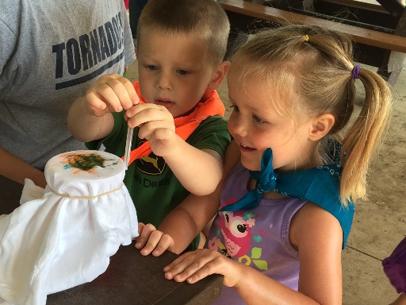

VOLUNTEER OPPORTUNITIES

Please contact Linda Rose, Naturalist, at Lrose@senecacountyparks.com for more information, unless otherwise noted.

- Monitor Bluebird and/or Purple Martin boxes

- Wildflower monitoring

- Archery support person--would have to attend a day (or half a day) training

- Tree planting--watch website for days and times

- Adopt a trail or park
INVASIVE SPECIES REMOVAL –
APRIL DATES:

Thursdays, April 14, 21, and 28 from 1pm – 2:30pm

April 14 will also have volunteer times from 5-6:30pm

We will be meeting at the Schekelhoff Nature Preserve parking lot.
If groups are interested in setting up additional community service times for their groups, please contact Sarah Betts at sbetts@senecacountyparks.com.

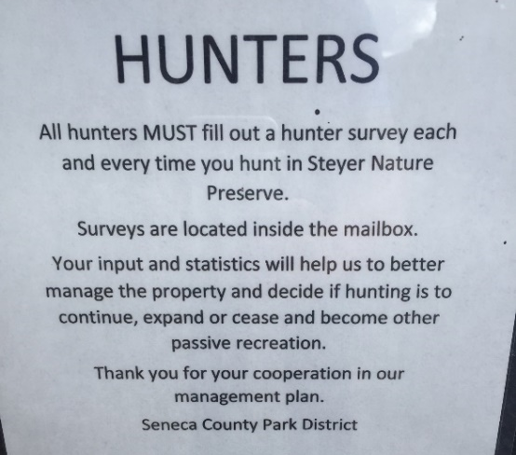
HUNTER SURVEYS:

We have been collecting hunter surveys for the past several years to gather base line information on the hunting at Steyer Nature Preserve. An example of the sign posted every year is included to the right.

HUNTER SURVEY RESULTS SUMMARY
STEYER NATURE PRESERVE

 | 2017/2018 | 2018/2019 | 2019/2020 | 2020/2021 | 2021/2022
# Surveys returned | 41 | 50 | 80 | 54 | 87
# Hours in field | 130 | 190 | 182.5 | 171.5 | 202.75
Species hunted
Squirrel | 12 | 13 | 23 | 11 | 28
White-tailed Deer | 13 | 21 | 51 | 35 | 44
Raccoon | 8 | 1 | 4 | 2
Coyote |  | 1
Eastern Cottontail | 2 | 1 |  | 2
Turkey |  | 5 |  | 1
Dove | * | * | * | * | 1
Pheasant | * | * | * | * | 1
Not specified | 9 | 7 | 3 | 3 | 16
Species harvested and number
Squirrel | 3 | 19 | 14 | 10 | 8
White-tailed Deer | 1 | 1 | 3 | 1 | 2
Coyote
Raccoon | 2 |  | 3 | 1
Eastern Cottontail
Turkey
Dove | * | * | * | *
Pheasant | * | * | * | *
Seneca County Resident | * | 20 | 40 | 31 | 45
Other County/State Resident | * | 19 | 26 | 20 | 30
Not specified | * | 1 | 14 | 3 | 12
*Not asked in survey that year

We know not all hunters filled out surveys, but all have been requested to do so as the results help us to determine the future management and use of the site.

